Name: Tushar Upadhyay
Reg. No: 12307313
University Name: Lovely Professional University

Minor Project
Binary Tree Traversal Visualizer
Question: Visual tool to understand inorder, preorder, and postorder traversals.
#include <iostream>
using namespace std;
// Define the structure for a tree node
struct Node {
int value;
Node* left;
Node* right;
Node(int val) : value(val), left(nullptr), right(nullptr) {}
};
// Class to represent the binary tree
class BinaryTree {
private:
Node* root;
public:
BinaryTree() : root(nullptr) {}

void addNode(int value) {
root = addNodeRec(root, value);
}

void inorderTraversal() {
cout << "Inorder Traversal: ";
inorderRec(root);
cout << endl;
}

void preorderTraversal() {
cout << "Preorder Traversal: ";
preorderRec(root);
cout << endl;
}

void postorderTraversal() {
cout << "Postorder Traversal: ";
postorderRec(root);
cout << endl;
}
private:
Node* addNodeRec(Node* node, int value) {
if (node == nullptr) {
return new Node(value);
}
if (value < node->value) {
node->left = addNodeRec(node->left, value);
} else {
node->right = addNodeRec(node->right, value);
}
return node;
}
// It will perform inorder traversal
void inorderRec(Node* node) {
if (node == nullptr) return;
inorderRec(node->left);
cout << node->value << " ";
inorderRec(node->right);
}
// It will perform preorder traversal
void preorderRec(Node* node) {
if (node == nullptr) return;
cout << node->value << " ";
preorderRec(node->left);
preorderRec(node->right);
}
// It will perform postorder traversal
void postorderRec(Node* node) {
if (node == nullptr) return;
postorderRec(node->left);
postorderRec(node->right);
cout << node->value << " ";
}
};
int main() {
BinaryTree tree;
int n, value;
cout << "Enter number of nodes: ";
cin >> n;
for (int i = 0; i < n; ++i) {
cout << "Enter node value: ";
cin >> value;
tree.addNode(value);
}
// It will perform traversals function
tree.inorderTraversal();
tree.preorderTraversal();
tree.postorderTraversal();

return 0;
}

CPP code Implementation:

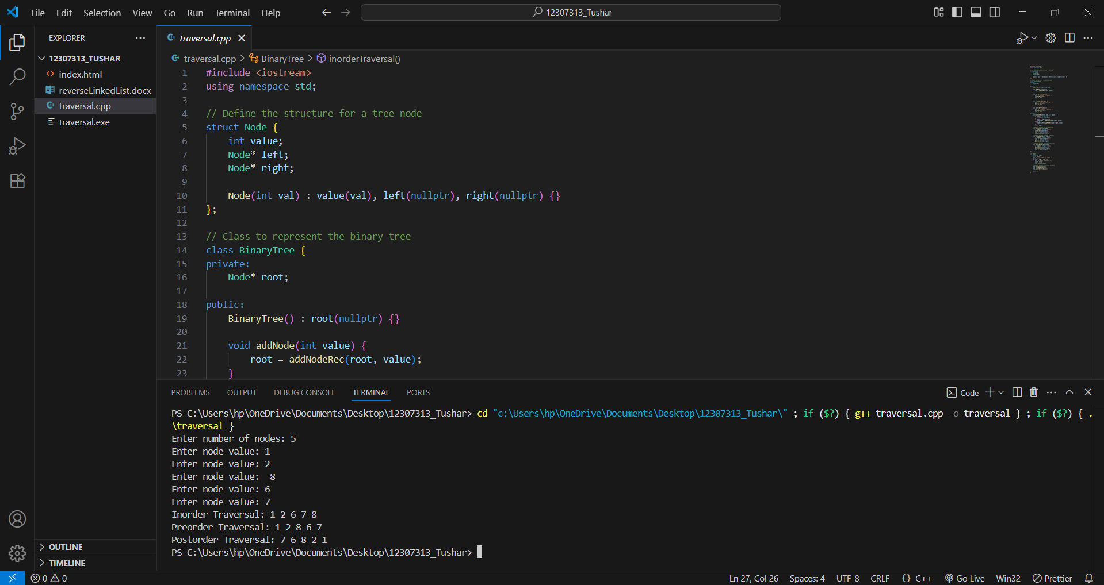

HTML CODE Implementation: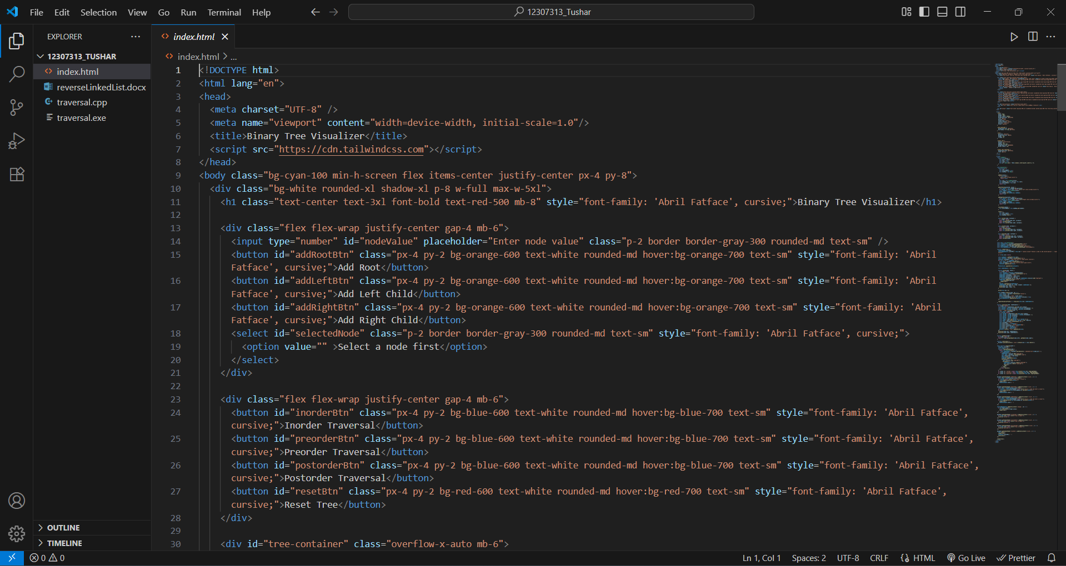

OUTPUT:
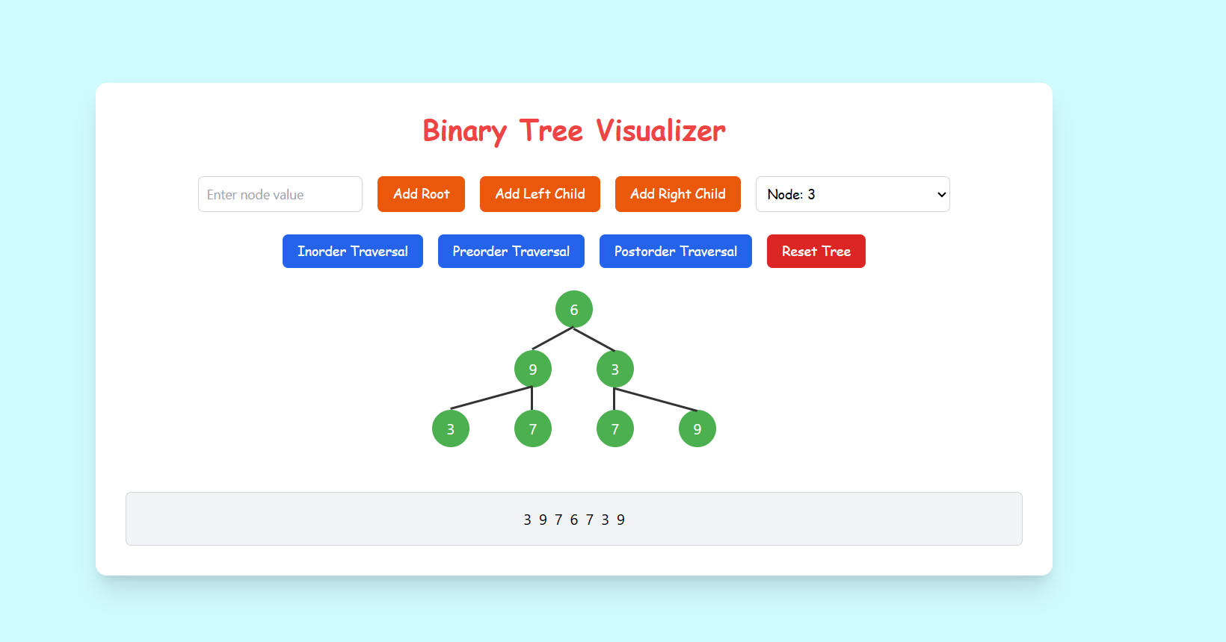

GitHub Repo Link: https://github.com/tusharupadhyay04/MinorProject-Binary-Tree-Traversal-Visualizer-
Live Demo: https://tusharupadhyay04.github.io/MinorProject-Binary-Tree-Traversal-Visualizer-/

